CHRISTMAS SPIRIT MARKET AT NARRYNA
Celebrate Christmas with Tasmania’s craft whisky and gin distillers
Saturday 10 December, 12 noon – 6pm

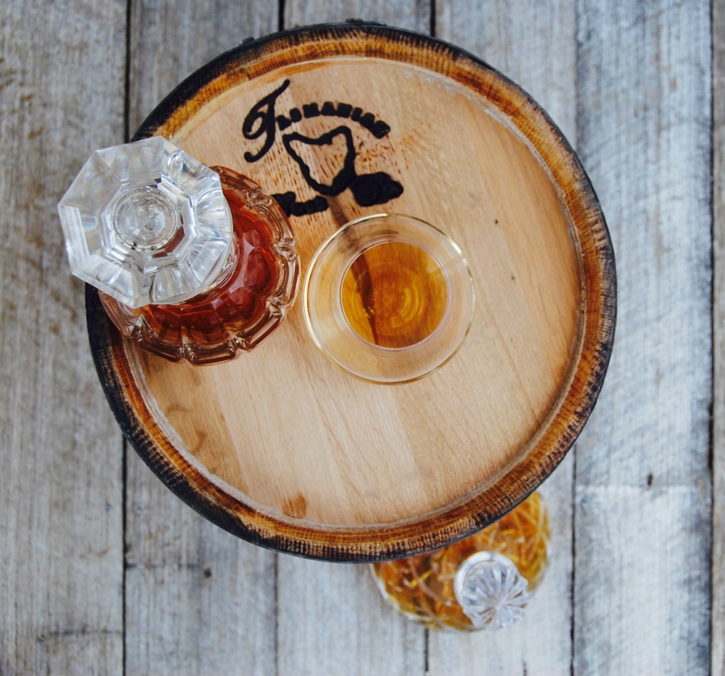

Are you a lover of Tasmanian whisky and craft spirits? Join Tasmanian distillers at Narryna on December 10th for the inaugural Christmas spirit market. This is the opportunity to meet the makers and choose that special tipple you share on Christmas day.

Narryna, built Salamanca Place’s first merchant, is the ideal setting for this Christmas fair. Funds raised will support Narryna, which celebrates 60 years as a museum in 2017. You will also be supporting Tasmania’s developing craft spirit tradition. Meet your friends for a Christmas beverage in Narryna’s beautiful grounds. Savour mince pies and plum pudding. The merchant’s house will be open and dressed for Christmas.

When: Saturday 10 December, 12 noon – 6pm
Where: Narryna 103 Hampden Road, Battery Point
Why: To support Narryna, support our craft distillers and share in the spirit of Christmas.

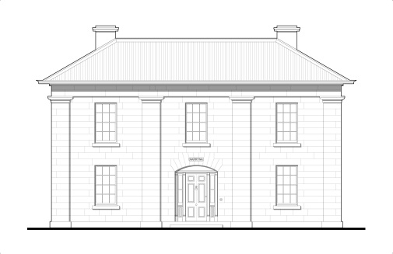
Narryna Heritage Museum Incorporated
103 Hampden Road, Battery Point, 7004
www.tmag.tas.gov.au/narryna
6234 2791

