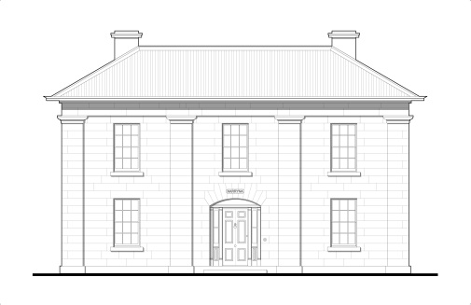
Narryna Heritage Museum Incorporated
103 Hampden Road, Battery Point, 7004
www.narryna.com.au
6234 2791

PRESS RELEASE

The Tasmanian design classic, the Peddle chair, is featured in a book and exhibition launch coming up at Narryna on Friday 9 September. The book is Denis Lake's The Men Who Made The CELEBRATED CHAIRS: Windsor-chair making in Tasmania. Narryna is welcoming Denis Lake's the book through two events - a seminar on the Peddle chair and Tasmanian vernacular chairs on Saturday 10th September and a popular ‘Peddle chair muster’ on Sunday 11 September. See the attached flyer for details.
Chair maker George Peddle (1855-1933) was born near West Wycombe, Buckinghamshire, 30 miles north-west of London. West Wycombe had been the centre for English ‘Windsor’ chair manufacture since the 18th century. George migrated to Hobart with his wife Caroline (nee Hearn) in 1884. From 1886 he manufactured chairs at Austin’s Ferry. In 1888 George set up as a chair maker in Launceston and in 1894 moved to Nabowla where he set up a saw milling business. At Nabowla he was joined by his brother-in-law, Harry Hearn (1856-1932), who continued ‘Peddle’ chair making until 1916. Nabowla was located on the Scottsdale railway line which assisted in getting milled timber and Peddle chairs to market.
The Peddle chair, as a Tasmanian version of the English ‘Windsor’ chair, was part of a living craft tradition. While George Peddle used steam-driven equipment in his timber mills, George and Harry hand-shaped the seats and backs of each Peddle chair and turned the Tasmanian blackwood legs and spindles on a foot-powered lathe. Denis Lake's study of differences in the turnings has allowed attribution of the designs to either George or Harry
The nine original Peddle chair designs – dining and office chairs, armchairs, rocking chairs, smoker’s chairs and children’s high chairs – survived a flood of factory-produced American and Australian-produced ‘Windsors’ and Thonet’s Austrian bentwood chairs. The Peddle chair maintained its market niche through its robustness and being sold at less than five shillings each. The chairs proved their worth in houses, homesteads, offices, libraries, schools and in railway waiting rooms. Others have since emulated the Peddle model, including the Inveresk railway workshops and Denis Lake, author of the new book on the Peddle chair.
While the English Windsor chair was painted, the Peddle chair was varnished or polished. It’s hard, dense Tasmanian blackwood allowed crisp turnings while the shaped seats and backs showed the grain to good effect. Each Peddle chair is a beautifully hand-crafted object. It appeals to our Arts-and-Crafts Movement influenced sensibilities now as in the late 19th century. As an antique that can be used on a daily basis, the Peddle chair provides a real link with past lives.
Contacts:
Scott Carlin, TMAG Manager – House Museums, Scott.Carlin@tmag.tas.gov.au or 0419 622 658
Denis Lake, author and furniture-maker, dr.rc.lake@bigpond.com or 6344 8694

