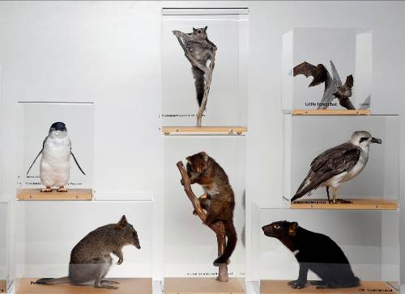

A large variety of specimens in cases are available for loan to schools, other organisations and community groups. They are great for sketching and research.

All loans are for a period of two weeks.

There are three different membership options for borrowing specimens:

1. Full year membership - $120 (inc. GST). This enables each participating school/group to borrow two specimens each fortnight throughout the year.
2. Term membership - $40 (inc. GST). This enables participating schools/groups to borrow two specimens each fortnight for a school term.
3. Single borrowing - $20 (inc. GST) per specimen (max. three specimens) for two weeks.

New borrowers need to make an appointment to sign up for the loan service. They will be shown where the collection is kept, sign the loan agreement form and borrow the first two specimens. An invoice will then be issued to the school. Specimens cannot be booked for particular dates, borrowers need to browse the collection at the time they wish to borrow a specimen.

If loans are not returned by the due date or returned damaged, a fine may be incurred by the borrower.

**Borrowers can return/change specimens from Monday to Thursday between 9:00 am – 5:00 pm and Fridays   
9:00 am – 3.45 pm. Loans are located at the reception area of Custom House, 19 Davey Street, Hobart.**

For further information, please email: [tmag.bookings@tmag.tas.gov.au](mailto:tmag.bookings@tmag.tas.gov.au) or phone 61657001

**\*A list of available specimens is on the back of this page\***

Other loan resources available:

* *Ice Boxes*

Antarctic Education resource boxes, for more information visit our website: <http://www.tmag.tas.gov.au/learning_and_discovery>)

* *Memorial Boxes*

Resources from the Australian War Memorial. For more information please visit the Australian War Memorial’s website: <http://www.awm.gov.au/education/schools/resources/memorial-boxes/>

* Freight charges apply for both these resources ($60 return for each resource)

Tasmanian Museum and Art Gallery

**Loan Service** 2017

**A list of the available specimens**

Mammals

1M Common brushtail possum

2M Common ringtail possum

3M Sugar glider

4M Water rat

5M Bennetts wallaby

6M Short-beaked echidna

7M Platypus

8M Tasmanian bettong

9M Long-nosed potoroo

10M Bandicoots (Southern brown and Eastern barred)

11M Spotted-tail quoll

12M Eastern quolls

13M Tasmanian devil (juvenile)

14M Tasmanian devil

15M Wombat (juvenile)

16M Little forest bats

17M Dusky antechinus

18M Tasmanian pademelon

Birds

1B Short-tailed shearwater

2B Short-tailed shearwater and chick

3B Black currawong

4B Grey currawong

5B Brown goshawk

6B Kookaburra

7B Green rosella

8B Tawny frogmouth

9B Tawny frogmouth

10B Little penguin (including education kit)

11B Yellow wattlebird

12B Green rosellas (3)

13B Brown falcon

14B Pied oystercatcher

15B Silver gulls

16B Swift parrots

17B. Southern boobook and mouse

18B White-headed petrel

19B Masked owl

20B Emperor penguin chicks and egg

21B Purple swamphen

22B Tasmanian honeyeaters (3 endemic)

23B Pacific gull

24B Black-faced cormorant and Great cormorant

25B Tasmanian native hen

26B Grey goshawk

27B Brown goshawk (juvenile)

Reptiles

1R Tiger snake

2R Tiger snake skin

3R Tiger snake skin  
4R Blotched blue-tongued lizard

5R White-lipped whip snake

6R Copperhead snake

7R Tasmanian skinks

Invertebrates

1I Australian spiny pipehorse

2I Insects and Insect leg adaptation.

Kits

1K Spider kit

2K Marine kit (rocky shores)

4K Mammal skulls

Geology

The geology kits are currently undergoing maintenance and will be available in 2017.

Useful websites for more information and photos of Tasmanian flora and fauna:

www.parks.tas.gov.au/wildlife/wildlife.html

<http://www.birdlife.org.au>